INSPECTION ABOUT FUNTIONALITY

INSPECTION TO GROUP 6

GROUP 3

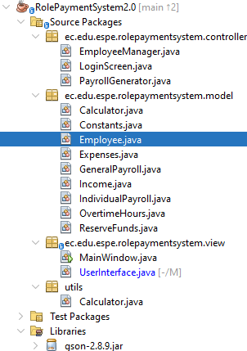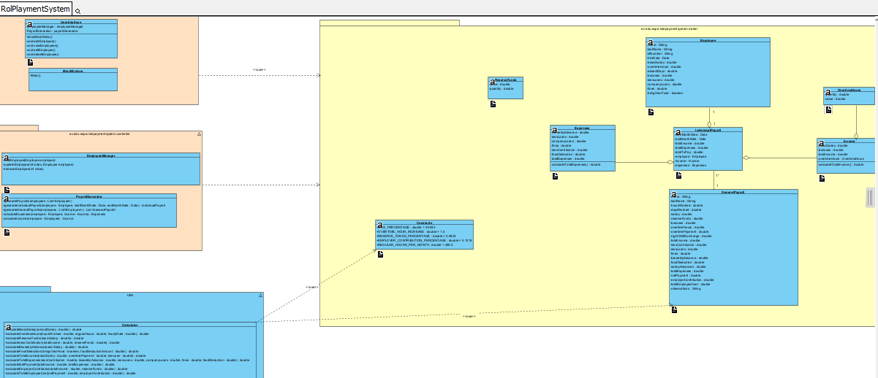

EmployeeManager. - consist the attributes and methods from the class diagrams in the code. OK

LoginScreen. - consist the attributes and methods from the class diagrams in the code. OK

PayRollGenerator. - consist the attributes and methods from the class diagrams in the code. OK

Constants. - consist the attributes and methods from the class diagrams in the code. OK

Employee. - consist the attributes and methods from the class diagrams in the code. OK

Expenses. - consist the attributes and methods from the class diagrams in the code. OK

GeneralPayRoll. - consist the attributes and methods from the class diagrams in the code. OK

IndividualPayRoll. - consist the attributes and methods from the class diagrams in the code. OK

OverTimeHours. - consist the attributes and methods from the class diagrams in the code. OK

ReserveFunds. - consist the attributes and methods from the class diagrams in the code. OK

MainWindow. - consist the attributes and methods from the class diagrams in the code. OK

UserInterface. - consist the attributes and methods from the class diagrams in the code. OK